Title: safety and effectiveness of oral anticoagulant use in dialysis patients with atrial fibrillation or atrial flutter in Hong Kong: a target trial emulation

Abstract

Introduction
Atrial fibrillation (AF) and atrial flutter (AFL) are types of supraventricular arrhythmias associated with an increased risk of ischemic stroke. These conditions can result in the formation of blood clots within the atrium, which may subsequently travel to the brain, leading to cardiovascular morbidity and mortality. Given the elevated risk of thromboembolic events, guidelines recommend the long-term use of oral anticoagulants (OACs) in the general population with AF or AFL. Agents such as warfarin and direct oral anticoagulants (DOACs), including dabigatran, rivaroxaban, apixaban, and edoxaban, are advised based on clinicians' discretion for high-risk patients with a CHA2DS2VASc score of one or above.
AF and AFL are common in patients with kidney failure. AF incidence in this group ranges from 11.6% to 22.2%, about 11 times higher than in the general population. AF and kidney failure together increase stroke or embolic risk by 1.8 to 2-fold. The heightened risk is likely due to shared cardiovascular risk factors like heart failure, hypertension, and diabetes. In dialysis patients with AF, both thromboembolic and bleeding risks are elevated, increasing mortality. This complicates OAC administration decisions.
Warfarin and DOACs' efficacy in dialysis patients is uncertain due to lack of RCTs and conflicting observational studies. Safety concerns and questionable OAC effectiveness in reducing stroke risk in dialysis patients led the KDIGO 2011 guideline to advise against OAC use in AF patients on dialysis. The 2023 AHA guideline, on the other hand, suggested warfarin and apixaban as options, with a weak class 2B recommendation, implying lack of clarity on effectiveness and safety. To further complicate the matter, a PD-first policy has been adopted for all patients with kidney failure requiring dialysis unless medically contraindicated in Hong Kong. Different dialysis modalities exhibit differences in removal rate, duration, pharmacokinetic profiles, and heparin use.
In light of the ongoing debate regarding the use of OACs in PD patients with atrial AF, this study seeks to assess the safety and efficacy of OAC administration in PD patients using a population-based electronic medical database from Hong Kong.

Method
Statistical analysis
Risks between OAC users and non-users are compared via difference and ratio. The probability of stroke is estimated using the pooled logistic models with indicators of month of follow-up and the baseline covariates: age, sex, comorbidities of myocardial infarction, stroke, and time from atrial fibrillation. Nonparametric bootstrapping with 500 samples is used to construct p

Results
Figure 1. Flow chart of eligible patients of the target trial with end-stage renal failure patients who underwent peritoneal dialysis, a Hong Kong CDARS database for the public from 2007 to 2022

Figure 2 Estimated risk of ischemic stroke (i) and haemorrhagic stroke (ii) incidence over 5 years, by oral drug, anticoagulants used or not, in end-stage renal failure with peritoneal dialysis, HK CDARS data 2007- 2022
- Cumulative incidence plot for ischemic stroke
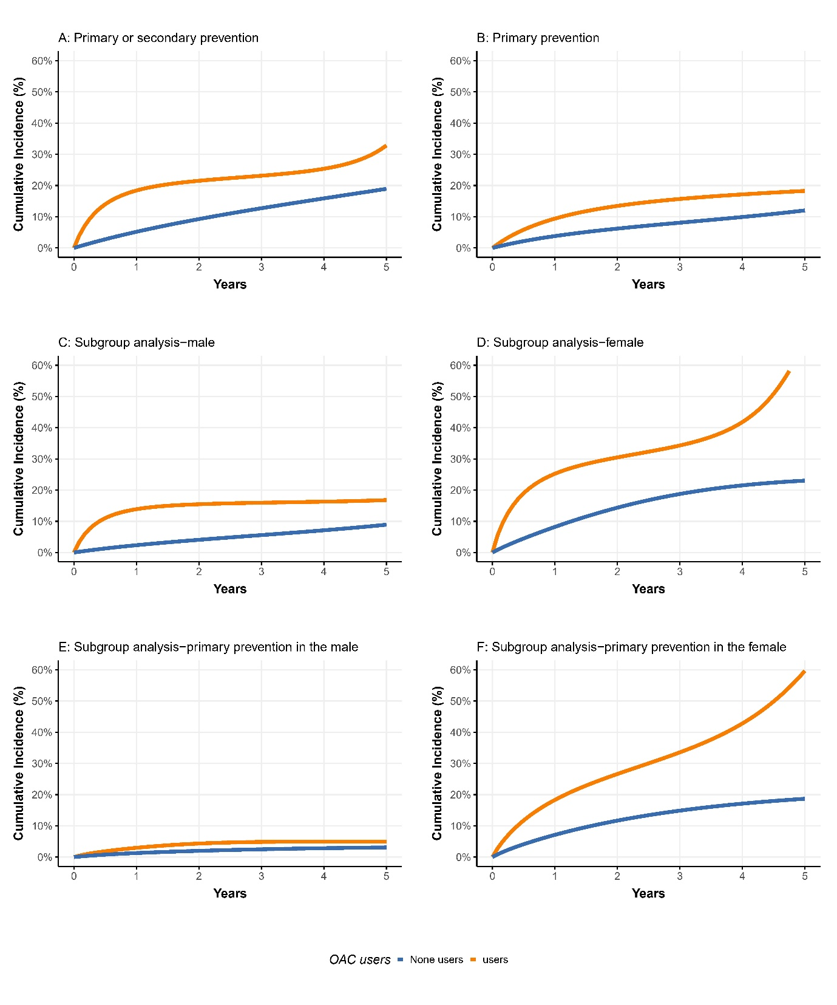

- Cumulative incidence plot for haemorrhagic stroke
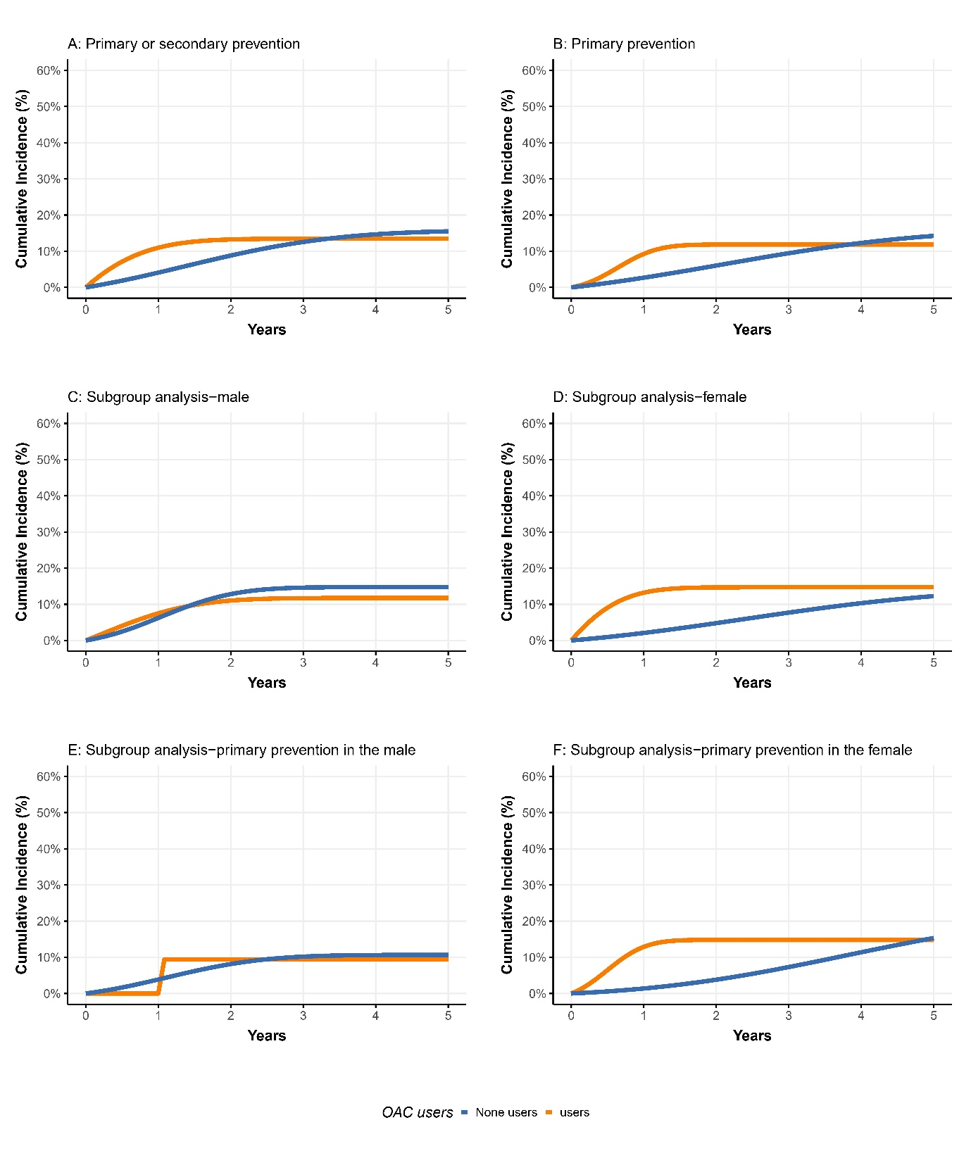

Table 1 Demographic information before and after the propensity score matching
Variables, n (%) | Before matching |  |  | After matching
 | Non-users  (N = 10245) | Users  (N = 109) | SMD | Non-users  (N = 893) | Users  (N = 107) | SMD
Follow-up period (median [IQR]) | 370.00 [152.00, 762.00] | 305.00 [64.00, 667.00] | 0.172 | 333.00 [128.00, 654.00] | 305.00 [68.50, 657.50] | 0.073
Sex, Male (%) | 5426 ( 53.0) | 55 ( 50.5) | 0.050 | 467 ( 52.3) | 54 ( 50.5) | 0.037
Age at index date (Years) (median [IQR]) | 68.60 [60.27, 75.83] | 67.44 [61.30, 73.44] | 0.002 | 68.26 [61.48, 74.49] | 67.44 [61.30, 73.79] | 0.050
Time from AF to Index date (Days) (median [IQR]) | 364.00 [150.00, 750.00] | 18.00 [9.00, 143.00] | 0.841 | 102.00 [43.00, 234.00] | 19.00 [9.00, 145.50] | 0.153
CHA₂DS₂-VASc Score (mean (SD)) | 3.83 (1.86) | 4.06 (1.89) | 0.127 | 4.15 (1.94) | 4.07 (1.89) | 0.047
Congestive Heart Failure | 3540 ( 34.6) | 36 ( 33.0) | 0.032 | 301 ( 33.7) | 35 ( 32.7) | 0.021
Myocardial infarction | 1671 ( 16.3) | 31 ( 28.4) | 0.294 | 266 ( 29.8) | 29 ( 27.1) | 0.060
Peripheral vascular disease | 1147 ( 11.2) | 10 ( 9.2) | 0.067 | 72 ( 8.1) | 10 ( 9.3) | 0.046
Cerebrovascular disease | 2602 ( 25.4) | 33 ( 30.3) | 0.109 | 298 ( 33.4) | 33 ( 30.8) | 0.054
Chronic obstructive pulmonary disease | 1200 ( 11.7) | 9 ( 8.3) | 0.115 | 62 ( 6.9) | 9 ( 8.4) | 0.055
Dementia | 238 ( 2.3) | 2 ( 1.8) | 0.034 | 28 ( 3.1) | 2 ( 1.9) | 0.081
Paralysis | 491 ( 4.8) | 3 ( 2.8) | 0.107 | 26 ( 2.9) | 3 ( 2.8) | 0.006
Diabetes | 5831 ( 56.9) | 73 ( 67.0) | 0.208 | 597 ( 66.9) | 72 ( 67.3) | 0.009
Chronic renal failure | 10242 (100.0) | 109 (100.0) | 0.024 | 893 (100.0) | 107 (100.0) | <0.001
Mild liver disease | 266 ( 2.6) | 2 ( 1.8) | 0.052 | 15 ( 1.7) | 2 ( 1.9) | 0.014
Moderate-severe liver disease | 75 ( 0.7) | 1 ( 0.9) | 0.020 | 9 ( 1.0) | 1 ( 0.9) | 0.007
Ulcers | 1641 ( 16.0) | 15 ( 13.8) | 0.063 | 121 ( 13.5) | 15 ( 14.0) | 0.014
Stroke or systemic embolism | 1478 ( 14.4) | 25 ( 22.9) | 0.220 | 231 ( 25.9) | 24 ( 22.4) | 0.080
Asthma | 376 ( 3.7) | 2 ( 1.8) | 0.112 | 19 ( 2.1) | 2 ( 1.9) | 0.018
Rheumatoid arthritis | 57 ( 0.6) | 1 ( 0.9) | 0.042 | 5 ( 0.6) | 0 ( 0.0) | 0.106
Acquired Immune Deficiency Syndrome (AIDS) | 0 (0.0) | 0 (0.0) | <0.001 | 0 (0.0) | 0 (0.0) | <0.001
Malignancy | 921 ( 9.0) | 10 ( 9.2) | 0.006 | 83 ( 9.3) | 10 ( 9.3) | 0.002
Metastatic solid tumour | 58 ( 0.6) | 1 ( 0.9) | 0.041 | 9 ( 1.0) | 1 ( 0.9) | 0.007
Diabetes without chronic complication | 4737 ( 46.2) | 59 ( 54.1) | 0.158 | 474 ( 53.1) | 58 ( 54.2) | 0.023
Diabetes with chronic complication | 4341 ( 42.4) | 52 ( 47.7) | 0.107 | 442 ( 49.5) | 52 ( 48.6) | 0.018
Hypertension | 9130 ( 89.1) | 99 ( 90.8) | 0.057 | 817 ( 91.5) | 97 ( 90.7) | 0.029
Severe Constipation | 2386 ( 23.3) | 19 ( 17.4) | 0.146 | 155 ( 17.4) | 19 ( 17.8) | 0.011
Antiplatelet user history | 8042 ( 78.5) | 78 ( 71.6) | 0.161 | 715 ( 80.1) | 76 ( 71.0) | 0.211

Table 2. Estimated 5-year risks of stroke in emulated target trials in end-stage renal failure with peritoneal dialysis, HK CDARS

 | Risk, % (95% CI) |  | Risk difference,% | Risk ratio
 | OAC non-users | OAC users
Ischemic stroke
Primary analysis | 0.19 (0.10, 0.42) | 0.33 (0.14, 0.70) | 0.14 (-0.15, 0.45) | 2.49 (1.39, 3.98)
Subgroup analysis
Male | 0.09 (0.04, 0.39) | 0.17 (0.06, 0.99) | 0.08 (-0.17, 0.85) | 2.58 (0.97, 4.78)
Female | 0.23 (0.11, 0.49) | 0.67 (0.10, 0.96) | 0.44 (-0.23, 0.76) | 2.50 (1.14, 4.37)
Incident case | 0.12 (0.06, 0.33) | 0.18 (0.07, 0.42) | 0.06 (-0.14, 0.26) | 1.94 (0.75, 3.61)
Incident male case | 0.52 (0.24, 0.70) | 0.36 (0.17, 1.00 ) | -0.16 (-0.39, 0.40) | 1.75 (1.05, 2.90)
Incident female case | 0.19 (0.08, 0.51) | 0.6 (0.06, 1.00) | 0.41 (-0.27, 0.80) | 3.19 (0.19, 8.24)
Hemorraghic stroke
Primary analysis | 0.16 (0.07, 0.41) | 0.13 (0.05, 0.25) | -0.02 (-0.30, 0.10) | 1.90 (0.80, 3.29)
Subgroup analysis
Male | 0.15 (0.07, 0.33) | 0.12 (<0.01, 1.00) | -0.03 (-0.24, 0.86) | 1.09 (<0.01, 2.9)
Female | 0.12 (0.02, 0.72) | 0.15 (0.05, 0.35) | 0.02 (-0.55, 0.22) | 3.53 (1.02, 9.81)
Incident case | 0.14 (0.05, 0.56) | 0.12 (0.05, 0.27) | -0.02 (-0.39, 0.11) | 1.84 (0.77, 3.81)
Incident male case | 0.11 (0.04, 0.36) | 0.09 (<0.01, 0.32) | -0.01 (-0.24, 0.21) | 0.88 (<0.01, 3.69)
Incident female case | 0.15 (0.01, 0.81) | 0.15 (0.04, 0.63) | -0.01 (-0.49, 0.31) | 0.97 (0.16, 22.11)
Note: Standardised by age, sex,
The 5-year risks under each screening strategy can be obtained via the discrete hazards (pooled logistic) regression model for the monthly probability of the outcome:

Table 3.Summary of the protocol of a target trial for studying the safety and effectiveness of oral coagulants in dialysis patients with atrial fibrillation or atrial flutter, and summary of the target trial is emulated using HK CDARS data.
Protocol component | Target trial | Emulation of the target trial using HK CDARS data
Eligibility criteria | People with end-stage renal failure undergoing peritoneal dialysis with a diagnosis of atrial fibrillation or atrial flutter aged 18 or older and who have not used oral coagulants. | The target trial is emulated using data in CDARS on people who were diagnosis with end-stage renal failure undergoing peritoneal dialysis with a newly diagnosis of atrial fibrillation or atrial flutter between 2007 and 2022. The emulation is performed using sequential trials approaches. At a given montly visit from 2007 to 2022, a person is defined as meeting the eligibility criteria if they meet the following conditions:  - Age 18 or older;  - Still underwent peritoneal dialysis;  - With a new diagnosis of atrial fibrillation or atrial flutter within the previous one month;  - Without any OAC prescription record before two months till 1993;  - Without hemodialysis, renal transplant before  The first visit at which the trial emulation eligibility criteria are met in the available data is denoted 𝑘=0 and subsequent trial times are 𝑘=1,2,…. The maximum number of visits is 192, with 𝑘=192 corresponding to the index date of 2022-12-01.
Treatment strategies | (i) Do not start using OAC.  (ii) Start using OAC. | The treatment strategies of interest are as in the target trial. The individuals who start to receive OAC within one month before the index date are treated as OAC users, while those without started OAC are treated as OAC non-users.
Assignment procedures | Patients randomly assigned to either treatment strategy. | At each trial, an individual is an OAC user or non‐user. A propensity score matching was used to emulate the randomization of eligible person-trials at baseline, where the users and non-users were matched in a 1:10 ratio within each trial. The nearest neighbour propensity score matching without replacement, with a propensity score estimated using logistic regression of the treatment on the covariates. The calliper value is set at 0.2 times the SD of the propensity score. The matching factors included demographic characteristics (sex and age at index), and baseline commorbidities (), in addition to the baseline trial ID for the emulation trials.
Follow‐up period | Starts at randomization and ends at death, stop peritoneal dialysis, start of hemodialysis, or renal transplant, loss‐to follow‐up, or 5 years of follow‐up, whichever occurs first. | MSM‐IPTW approach: Follow‐up starts at 𝑘=0 and ends at death or transplant,or the end of 2022, whichever occurs first.
 |  | Sequential trials approach: A trial is formed from each visit 𝑘=0,1,…. Trial 𝑘 includes individuals meeting the trial emulation eligibility criteria at visit 𝑘 (𝑘=0,1,...,9). In trial 𝑘 follow‐up starts at time 𝑘 and ends at switching away from the treatment status at visit 𝑘, death or transplant, loss to follow‐up, or the end of 2022, whichever occurs first.
Outcome | For safety events, ischemic stroke or death  For effectiveness, haemorrhagic stroke | As in the target trial.
Causal contrasts | Intention to treat effect. The patients will be assigned according to their assignment at baseline, no matter the change during follow-up.  Per protocol treatment effect. Marginal survival curves up to 11 years under the two treatment strategies, and corresponding marginal risk differences. For the marginal probabilities, the population of interest is individuals meeting the target trial eligibility criteria in 2018. | The causal contrasts of interest are as in the target trial. Estimation uses the propensity score matching approach and the approach of the sequential trial.

Discussion

References

